**Winton Primary School Fox Street Winton Victoria 3675**

Ph: (03) 5766 4233

**PARENT PAYMENT ARRANGEMENTS 2023**

17th November 2022

Dear parent/guardian,

*Winton Primary School* is looking forward to another great year of teaching and learning and would like to advise you of *Winton Primary School*’s voluntary financial contributions for *2023.*

Schools provide students with education to fulfil the standard Victorian curriculum and we want to assure you that all contributions are voluntary. Nevertheless, the ongoing support of our families ensures that our school can offer the best possible education and support for our students. We want to thank you for all your support, whether that’s through fundraising or volunteering your time. This has made a huge difference to our school and the programs we can offer.

For further information on the Department’s Parent Payments Policy please see a one-page overview attached.

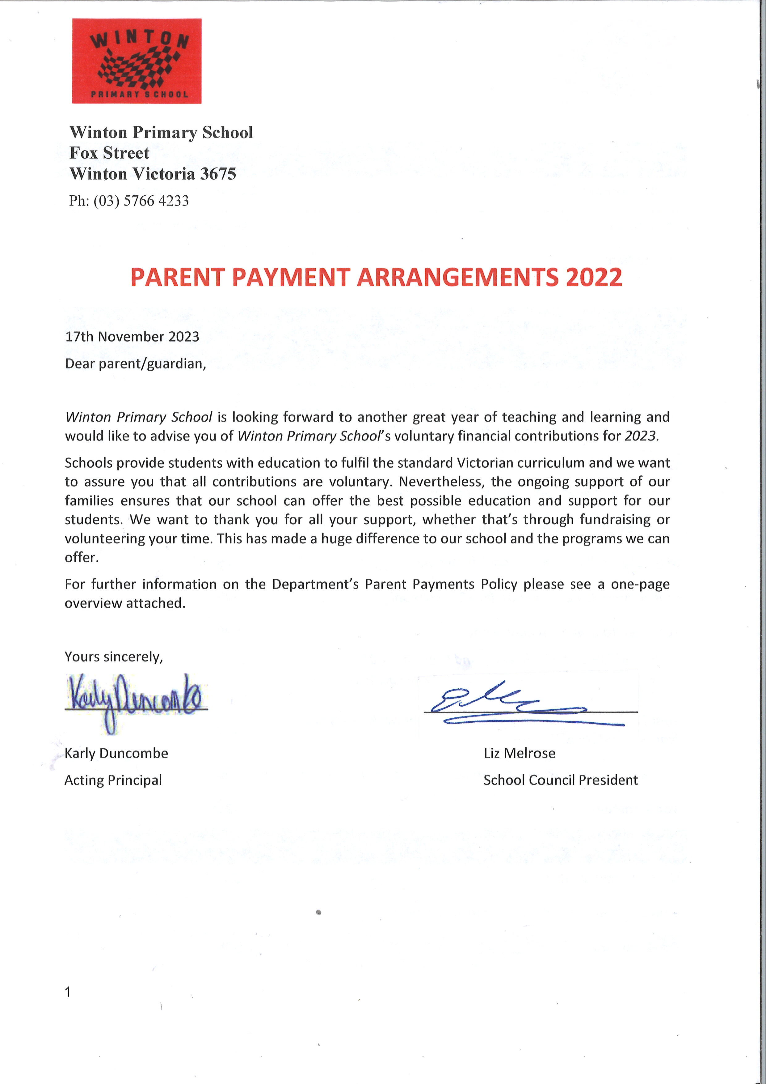Yours sincerely,



Karly Duncombe Liz Melrose

Acting Principal School Council President

|  |
| --- |
| **Student Details** |
| **Student Name: Student Year level:** |
| **Student Name: Student Year level:** |
| **Family Name:** |

|  |  |  |  |
| --- | --- | --- | --- |
| **Curriculum Contributions** - items and activities that are necessary for students use, or participate in, to access the Curriculum | Amount  Per child | **Number of children** | Total |
| *Year Prep to 6 classroom consumables, materials & equipment*   * *Stationery – including writing books, scrap books, maths workbooks, My Home Reader Journal books.* | $30 |  |  |
| *Year Prep to 6 Online Subscriptions*   * *Soundwaves book and logon - Annual* | $30 |  |  |
| * *Essential Assessments subscription and log in - Annual* | $25 |  |  |
| *Mobile Area Craft Centre (MACC) - Annual* | $25 |  |  |
| *Mobile Area Resource Centre (MARC) - Annual* | $25 |  |  |
| *Year Prep to 6 whole school events*   * *Athletics carnival - entry and transport ($10)* * *Swimming carnival – entry and transport ($10)* | $20 |  |  |
| *Year Prep to 6 Printing and photocopying of worksheets and learning materials* | $20 |  |  |
| *Kitchen/Garden cooking ingredients - $15 per term - Year P to 6* | $60 |  |  |
| **Total Amount** | **$235** |  |  |
| **Other Contributions -** for non-curriculum items and activities | **Amount** |  |  |
| *First aid equipment* | $5 |  |  |
| *School grounds maintenance and improvements* | $20 |  |  |
| **Total Amount** | **$25** |  |  |

**Educational items for students to own**

Below is a list of items that the school recommends you purchase for your child to individually own and use.

Please **NAME** all items prior to bringing to school on the first day.

|  |
| --- |
| * Pencil Case – Own Choice * Set of 12 coloured pencils * Set of 12 Textas * Set of Crayons * Glue Sticks X 4 |

**Extra-Curricular Items and Activities**

*Winton Primary School* offers a range of items and activities that enhance or broaden the schooling experience of students and are above and beyond what the school provides in order to deliver the Curriculum. These are provided on a user-pays basis.

If you would like to purchase an item or activity for your child, please indicate on the table below and return this to the school by *Friday 9th December 2022*

|  |  |  |  |  |
| --- | --- | --- | --- | --- |
| **Extra-Curricular Items and Activities** | **Amount**  **Per**  **child** | **Purchase**  **(Please tick)** | **Number of children** | **Total** |
| *2 X Ovens Learning Community cluster days - Year P to 6* | $30 |  |  |  |
| *Optional Prep/1/2 major excursion deposit (Approx 80)* | $50 |  |  |  |
| *Optional Year 3 /4 camp deposit* *(Approx $350)* | $100 |  |  |  |
| *Optional Year 5 /6 camp deposit* *(Approx $450)* | $100 |  |  |  |
| *Optional Grade P to 6 Swimming Program deposit* | $50 |  |  |  |
| *Hands On Science Workshop – Year P to 6*  *(Held at Glenrowan Primary School)* | $15 |  |  |  |
| *Other optional Year Prep to 6 camps and excursions to be scheduled* | *TBA* |  |  |  |
| **Total Extra-curricular Items and Activities** |  |  |  |  |
|  |  |  |  |  |

### Financial Support for Families

*Winton Primary School* understands that some families may experience financial difficulty and offers a range of support options, including:

**Please tick √**

|  |  |
| --- | --- |
| * Camps, Sports and Excursions Fund (concession card holders eligible only) |  |
| * ***Option A*** (full amount at the beginning of Term 1) |  |
| * **Option B** (payment at the beginning of each Term) |  |
| * **Option C** (half yearly payment- Terms 1 & 3) |  |
| * **Option D** (other payment arrangements)*   (*If selecting Option D please make an appointment with the school to discuss your circumstances and the available options)* |  |

For a confidential discussion about accessing these services, or if you would like to discuss alternative payment arrangements, contact: *Anne Hanrahan; Business Manager*

Ph: 03 *57662221* | Email: [*anne.hanrahan@education.vic.gov.au*](mailto:anne.hanrahan@education.vic.gov.au)

**Total**

|  |  |
| --- | --- |
| **Category** |  |
| Curriculum Contributions | $ |
| Other Contributions | $ |
| Extra-Curricular Items and Activities | $ |

**Payment methods:** *Please select your method of payment:*

 **Cheque** *(Make payable to Winton Primary School)*

 **Direct credit at the Commonwealth Bank:**

**BSB** 063 505 **Account no.** 1004490

Please included description of payment: Student’s full name - School fees

 **Centrepay** - please contact Anne Hanrahan at Glenrowan PS if you wish to set up Centrepay payments

 **BPAY** – Your BPAY payment codes are included on your family statement, provided separately to this notice

### Refunds

### *Parent requests for refunds are subject to the discretion of the school and made on a case-by-case basis. Refunds will be provided where the school deems it is reasonable and fair to do so, taking into consideration whether a cost has been incurred, the Department’s Parent Payment Policy and Guidance, Financial Help for Families Policy and any other relevant information.*

**parent PAYMENTS policy**

**ONE PAGE OVERVIEW**

|  |  |
| --- | --- |
|  | FREE INSTRUCTION   * Schools provide students with free instruction and ensure students have free access to all items, activities and services that are used by the school to fulfil the standard curriculum requirements in Victorian Curriculum F-10, VCE and VCAL. * Schools may invite parents to make a financial contribution to support the school. |

|  |  |  |  |  |
| --- | --- | --- | --- | --- |
|  | PARENT PAYMENT REQUESTS  Schools can request contributions from parents under three categories:   |  |  |  | | --- | --- | --- | | Curriculum Contributions  Voluntary financial contributions for curriculum items and activities which the school deems necessary for students to learn the Curriculum. | Other  Contributions  Voluntary financial contributions for non-curriculum items and activities that relate to the school’s functions and objectives. | Extra-Curricular Items and Activities  Items and activities that enhance or broaden the schooling experience of students and are above and beyond what the school provides for free to deliver the Curriculum. These are provided on a user-pays basis. |  * Schools may also invite parents to supply or purchase educational items to use and own (e.g. textbooks, stationery, digital devices). |

|  |  |
| --- | --- |
|  | FINANCIAL HELP FOR FAMILIES   * Schools put in place financial hardship arrangements to support families who cannot pay for items or activities so that their child doesn’t miss out. * Schools have a nominated parent payment contact person(s) that parents can have a confidential discussion with regarding financial hardship arrangements. |

|  |  |
| --- | --- |
|  | SCHOOL PROCESSES   * Schools must obtain school council approval for their parent payment arrangements and publish all requests and communications for each year level on their school website for transparency. |

